STUDY GUIDE
Biochemistry-1
1211211 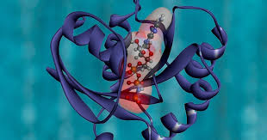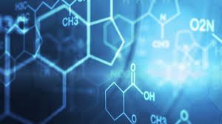 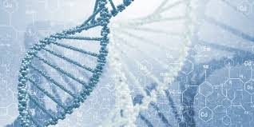

Course coordination
Female section Dr. Naglaa Mokhtar (Naglaa.Ibrahim@nbu.edu.sa)
Male section Dr. Abdelnaser Badway (abdelnaser.ali@nbu.edu.sa)
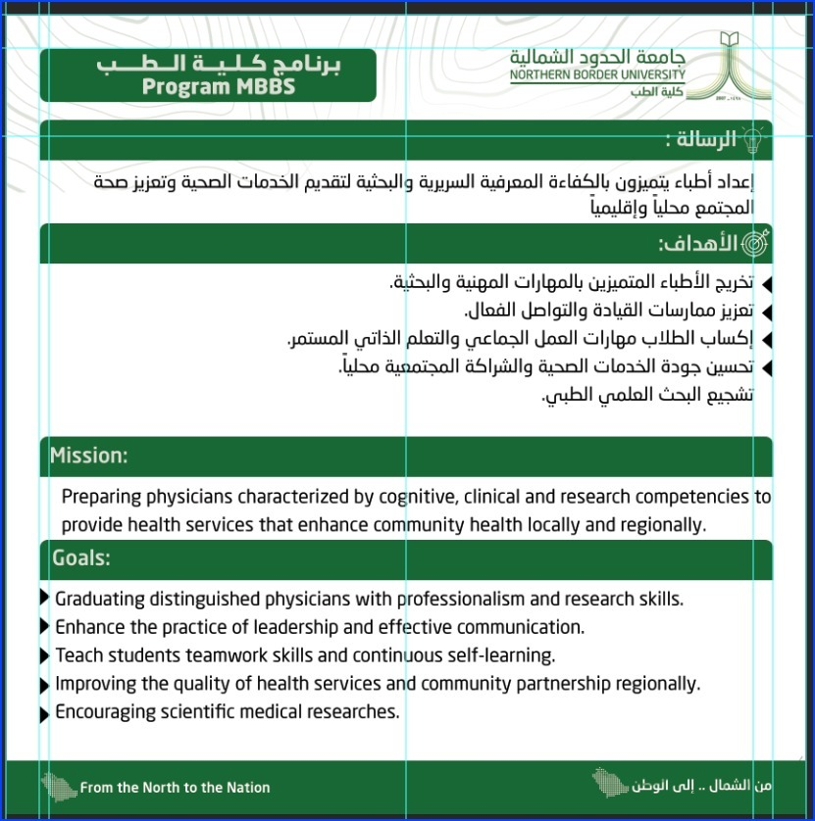

Course Identification
1. Credit hours | 5
2. Level/year at which this course is offered | 2nd year – 5th semester
3. Pre-requisites for this course | Pass in 1st year

Course contributors names
1- Prof. Manal Said Fawzy
2- Dr. Abdelnaser Badway
3- Dr. Naglaa Mokhtar

Actual Learning Hours (Copy and paste the table from courses specification)
No | Activity | Learning Hours
Contact Hours
1 | Lecture | 63
2 | Laboratory/Studio | 9
3 | Tutorial | -
4 | Others (specify) | -
 | Total | 72

Course Objectives (Copy and paste the table from courses specification)

1. Course Description
The course focuses on the structure and biological functions of carbohydrates, proteins, nucleotides, vitamins, enzymes, isozymes, and cell membranes. The course discusses the regulation and inhibition of enzyme activities and diseases produced by vitamin deficiencies. The course illustrates the structure and function of nucleic acids and different steps of DNA replication and repair, transcription, genetic code, mutation, protein biosynthesis, regulation of gene expression, and recombinant DNA technologies. Finally, the course describes the meaning of bioenergetics, oxidative phosphorylation, electron transport chain and its inhibitors, and mechanism of action of uncouplers.

2. Course Main Objectives
- Recognize the different biochemical components of human bodies e.g. carbohydrates, proteins, lipids, enzymes, coenzymes, vitamins, nucleic acids, minerals, cell membrane, and electron transport chain.
- Summarize the variable molecular bioengineering processes e.g., DNA replication and repair, transcription, translation, mutation, and recombinant DNA technologies.
- Analyze the component of unknown organic solutions, carbohydrates, proteins, lipids, urea, and uric acid.
- Appraise the energy released from different biochemical reactions inside the body.
- Demonstrate the different biochemical techniques e.g., Colorimeter, spectrophotometer, HPLC, electrophoresis, DNA extraction, and PCR.

Course Learning Outcomes (Copy and paste the table from courses specification)
CLOs |  | Aligned PLOs
1 | Knowledge and Understanding
1.1 | Describe classifications, structure, properties, synthesis, and biological functions of carbohydrates, lipids, and proteins and define their assembly in connective tissue and cell membrane | K1
1.2 | Recognize the mechanism of action and functions of vitamins, minerals, and enzymes and their regulatory roles in metabolism, growth, and development | K1
1.3 | State the steps of DNA replication, damage and repair, RNA transcription, and protein synthesis and their roles in hereditary diseases | K1
2 | Skills:
2.1 | Apply the common laboratory techniques used to study carbohydrates, lipids, proteins, minerals, vitamins, and genetic material and interpret their data. | S2
2.2 | Apply the core-writing skills to express his knowledge and ideas | S6
3 | Values:
3.1 | Employ the skill of self-learning through updated medical information from different approved sources | V1

Course Content (Copy and paste the table from courses specification)
No | List of Topics | Contact Hours
1 | Classification of carbohydrates &Structure of monosaccharaides | 2
2 | Isomerism- Derived sugars &Disaccharides | 2
3 | Polysaccharides | 2
4 | Amino acids Classification, Properties | 2
5 | Structure of amino acids | 2
6 | Higher orders of proteins and folding process | 2
7 | Globular proteins: HB & myoglobin | 2
8 | Fibrous proteins | 2
9 | Simple lipids | 2
10 | Phospholipids- Glycolipids | 2
11 | Lipoproteins – Steroids | 2
12 | Practical: Physical chemistry | 1
13 | Practical: Physical chemistry | 1
14 | Practical: Physical chemistry | 1
15 | Chemical nature of the enzymes & classification  Mechanism of action | 2
16 | Factors affecting rate of enzyme action | 2
17 | Regulation of enzyme activities- Enzyme inhibition | 2
18 | Enzymes in Clinical Diagnosis- isozymes | 1
19 | Nucleotides | 1
20 | DNA structure &DNA organization. | 2
21 | DNA replication | 2
22 | DNA damage& repair | 1
23 | RNA | 1
24 | Transcription | 2
25 | Genetic code & mutation | 2
26 | Protein synthesis- Posttranslational modification | 2
27 | Regulation of gene expression | 2
28 | DNA recombinant technology & applications | 2
29 | Chemical structure of cell membrane | 1
30 | Vitamin C - vitamin B1 & B2 | 1
31 | B3 & B5, | 2
32 | B6, B7, B9, B10 | 2
33 | Practical: HPLC | 1
34 | Practical: isozymes | 1
35 | Vitamin A, D | 2
36 | Vitamin E, K | 2
37 | Practical: DNA extraction | 1
38 | Practical: electrophoresis | 1
39 | Practical: PCR | 1
40 | Major minerals: Na+, K+, Cl-, Mg2+, Ca2+, Ph, S....etc. | 2
41 | Trace elements: Iron, Copper, Zinc ….etc | 1
42 | Practical: calcium estimation | 1
43 | Redox chain | 1
44 | free energy | 1
45 | Oxidative phosphorylation | 2
Total |  | 72

Teaching strategies and Assessment Methods for Students (Copy and paste the table from courses specification)

Code | Course Learning Outcomes | Teaching Strategies | Assessment Methods
1.0 | Knowledge and Understanding
1.1 | Describe classifications, structure, properties, synthesis, and biological functions of carbohydrates, lipids, and proteins and define their assembly in connective tissue and cell membrane | Direct instructional (Lectures) | Written exams (MCQs & SAQs).
1.2 | Recognize the mechanism of action and functions of vitamins, minerals, and enzymes and their regulatory roles in metabolism, growth, and development | Direct instructional (Lectures) | Written exams (MCQs & SAQs).
1.3 | State the steps of DNA replication, damage and repair, RNA transcription, and protein synthesis and their roles in hereditary diseases | Direct instructional (Lectures) | Written exams (MCQs & SAQs).
2.0 | Skills
2.1 | Apply the common laboratory techniques which are used to study carbohydrates, lipids, proteins, minerals, vitamins, and genetic material and interpret their data | Direct instructional (Lab demonstration) | OSPE
2.2 | Apply the core-writing skills to express his knowledge and ideas | Homework-assignment | Assignment rubric
3.0 | Values
3.1 | Employ the skill of self-learning through updated medical information from different approved sources | Homework-assignment | Assignment rubric

Assessment Tasks for Students (Copy and paste the table from courses specification)
# | Assessment task* | Week Due | Percentage of Total Assessment Score
2 | Midterm | 6th | 25%
3 | Assignment | 10th | 15%
4 | OSPE | End of semester | 20%
5 | Final exam | End of semester | 40%

Course blueprint (% of total summative marks in blueprint is to be given in the range)
Topics | Teaching strategies | Assessment methods | Knowledge & Understanding |  |  | Skills |  |  | Values |  |  | % of total contact hours | % of total summative marks
Topics | Teaching strategies | Assessment methods | K1 | K2 | … | S1 | S2 | S6 | V1 | V | … | % of total contact hours | % of total summative marks
Classification of carbohydrates &Structure of monosaccharaides | Direct instructional (Lectures) | Written exams (MCQs & SAQs) | K1 | - | - | - | - | S6 | V1 | - | - | 2.8% | 2-3
Isomerism- Derived sugars &Disaccharides | Direct instructional (Lectures) | Written exams (MCQs & SAQs) | K1 | - | - | - | - | S6 | V1 | - | - | 2.8% | 2-3
Polysaccharides | Direct instructional (Lectures) | Written exams (MCQs & SAQs) | K1 | - | - | - | - | S6 | V1 | - | - | 2.8% | 2-3
Amino acids Classification, Properties | Direct instructional (Lectures) | Written exams (MCQs & SAQs) | K1 | - | - | - | - | S6 | V1 | - | - | 2.8% | 2-3
Structure of amino acids | Direct instructional (Lectures) | Written exams (MCQs & SAQs) | K1 | - | - | - | - | S6 | V1 | - | - | 2.8% | 2-3
Higher orders of proteins and folding process | Direct instructional (Lectures) | Written exams (MCQs & SAQs) | K1 | - | - | - | - | S6 | V1 | - | - | 2.8% | 2-3
Globular proteins: HB & myoglobin | Direct instructional (Lectures) | Written exams (MCQs & SAQs) | K1 | - | - | - | - | S6 | V1 | - | - | 2.8% | 2-3
Fibrous proteins | Direct instructional (Lectures) | Written exams (MCQs & SAQs) | K1 | - | - | - | - | S6 | V1 | - | - | 2.8% | 2-3
Simple lipids | Direct instructional (Lectures) | Written exams (MCQs & SAQs) | K1 | - | - | - | - | S6 | V1 | - | - | 2.8% | 2-3
Phospholipids- Glycolipids | Direct instructional (Lectures) | Written exams (MCQs & SAQs) | K1 | - | - | - | - | S6 | V1 | - | - | 2.8% | 2-3
Lipoproteins – Steroids | Direct instructional (Lectures) | Written exams (MCQs & SAQs) | K1 | - | - | - | - | S6 | V1 | - | - | 2.8% | 2-3
Chemical nature of the enzymes & classification &Mechanism of action | Direct instructional (Lectures) | Written exams (MCQs & SAQs) | K1 | - | - | - | - | S6 | V1 | - | - | 2.8% | 2-3
Factors affecting rate of enzyme action | Direct instructional (Lectures) | Written exams (MCQs & SAQs) | K1 | - | - | - | - | S6 | V1 | - | - | 2.8% | 2-3
Regulation of enzyme activities- Enzyme inhibition | Direct instructional (Lectures) | Written exams (MCQs & SAQs) | K1 | - | - | - | - | S6 | V1 | - | - | 2.8% | 2-3
Enzymes in Clinical Diagnosis- isozymes | Direct instructional (Lectures) | Written exams (MCQs & SAQs) | K1 | - | - | - | - | S6 | V1 | - | - | 1.4% | 1-2
Nucleotides | Direct instructional (Lectures) | Written exams (MCQs & SAQs) | K1 | - | - | - | - | S6 | V1 | - | - | 1.4% | 1-2
DNA structure &DNA organization. | Direct instructional (Lectures) | Written exams (MCQs & SAQs) | K1 | - | - | - | - | S6 | V1 | - | - | 2.8% | 2-3
DNA replication | Direct instructional (Lectures) | Written exams (MCQs & SAQs) | K1 | - | - | - | - | S6 | V1 | - | - | 2.8% | 2-3
DNA damage& repair | Direct instructional (Lectures) | Written exams (MCQs & SAQs) | K1 | - | - | - | - | S6 | V1 | - | - | 1.4% | 1-2
RNA | Direct instructional (Lectures) | Written exams (MCQs & SAQs) | K1 | - | - | - | - | S6 | V1 | - | - | 1.4% | 1-2
Transcription | Direct instructional (Lectures) | Written exams (MCQs & SAQs) | K1 | - | - | - | - | S6 | V1 | - | - | 2.8% | 2-3
Genetic code & mutation | Direct instructional (Lectures) | Written exams (MCQs & SAQs) | K1 | - | - | - | - | S6 | V1 | - | - | 2.8% | 2-3
Protein synthesis- Posttranslational modification | Direct instructional (Lectures) | Written exams (MCQs & SAQs) | K1 | - | - | - | - | S6 | V1 | - | - | 2.8% | 2-3
Regulation of gene expression | Direct instructional (Lectures) | Written exams (MCQs & SAQs) | K1 | - | - | - | - | S6 | V1 | - | - | 2.8% | 2-3
DNA recombinant technology & applications | Direct instructional (Lectures) | Written exams (MCQs & SAQs) | K1 | - | - | - | - | S6 | V1 | - | - | 2.8% | 2-3
Chemical structure of cell membrane | Direct instructional (Lectures) | Written exams (MCQs & SAQs) | K1 | - | - | - | - | S6 | V1 | - | - | 1.4% | 1-2
Vitamin C - vitamin B1 & B2 | Direct instructional (Lectures) | Written exams (MCQs & SAQs) | K1 | - | - | - | - | S6 | V1 | - | - | 1.4% | 1-2
B3 & B5, | Direct instructional (Lectures) | Written exams (MCQs & SAQs) | K1 | - | - | - | - | S6 | V1 | - | - | 2.8% | 2-3
B6, B7, B9, B10 | Direct instructional (Lectures) | Written exams (MCQs & SAQs) | K1 | - | - | - | - | S6 | V1 | - | - | 2.8% | 2-3
Vitamin A, D | Direct instructional (Lectures) | Written exams (MCQs & SAQs) | K1 | - | - | - | - | S6 | V1 | - | - | 2.8% | 2-3
Vitamin E, K | Direct instructional (Lectures) | Written exams (MCQs & SAQs) | K1 | - | - | - | - | S6 | V1 | - | - | 2.8% | 2-3
Major minerals: Na+, K+, Cl-, Mg2+, Ca2+, Ph, S....etc. | Direct instructional (Lectures) | Written exams (MCQs & SAQs) | K1 | - | - | - | - | S6 | V1 | - | - | 2.8% | 2-3
Trace elements: Iron, Copper, Zinc ….etc | Direct instructional (Lectures) | Written exams (MCQs & SAQs) | K1 | - | - | - | - | S6 | V1 | - | - | 1.4% | 1-2
Redox chain | Direct instructional (Lectures) | Written exams (MCQs & SAQs) | K1 | - | - | - | - | S6 | V1 | - | - | 1.4% | 1-2
free energy | Direct instructional (Lectures) | Written exams (MCQs & SAQs) | K1 | - | - | - | - | S6 | V1 | - | - | 1.4% | 1-2
Oxidative phosphorylation | Direct instructional (Lectures) | Written exams (MCQs & SAQs) | K1 | - | - | - | - | S6 | V1 | - | - | 2.8% | 2-3
Practical:  physical chemistry | Lab. based | OSPE | - | - | - | - | S2 | - | - | - | - | 1.4% | 2-3
Practical:  physical chemistry | Lab. based | OSPE | - | - | - | - | S2 | - | - | - | - | 1.4% | 2-3
Practical:  physical chemistry | Lab. based | OSPE | - | - | - | - | S2 | - | - | - | - | 1.4% | 2-3
Practical: HPLC | Lab. based | OSPE | - | - | - | - | S2 | - | - | - | - | 1.4% | 2-3
Practical: isozymes | Lab. based | OSPE | - | - | - | - | S2 | - | - | - | - | 1.4% | 2-3
Practical: DNA extraction | Lab. based | OSPE | - | - | - | - | S2 | - | - | - | - | 1.4% | 2-3
Practical: electrophoresis | Lab. based | OSPE | - | - | - | - | S2 | - | - | - | - | 1.4% | 2-3
Practical: PCR | Lab. based | OSPE | - | - | - | - | S2 | - | - | - | - | 1.4% | 2-3
Practical: calcium estimation | Lab. based | OSPE | - | - | - | - | S2 | - | - | - | - | 1.4% | 2-3

Learning Resources (Copy and paste the table from courses specification)
Required Textbooks | Lippincott's Illustrated Reviews of Biochemistry, 7th edition (2017): Richard A. Harvey, & Denise R. Ferrier. Lippincott's Williams & Wilkins.
Essential References Materials | Harpers Illustrated Biochemistry: 31st Edition (2018): Victor W. Rodwell, David Bender. The McGraw Hill Education.  Textbook-of-Biochemistry-For-Medical-Students-6th-Edition (2011). DM-Vasudevan, Sreekumari S, Kannan Vaidyanathan
Electronic Materials | https://www.acb.org.uk/our-resources/biochemistry.html  https://www.asbmb.org/education/online-teaching/online-lab-work  https://biochem.oregonstate.edu/content/biochemistry-free-and-easy  - other websites updated each year
Other Learning Materials | - Department lectures power points.

Related check lists
PBL
Assignment
Clinical skills checklist
Presentation checklist √
Project checklist
Workshop checklist
(Checklist must be aligned with the learning outcomes)

Course quality evaluation
After the end of the course, please give your FEEDBACK through the following link:

https://docs.google.com/forms/d/1IKf4va0FSQSr-7MCXVpdaTsni9W7WYZ6WPVzVO-Z65A/edit

