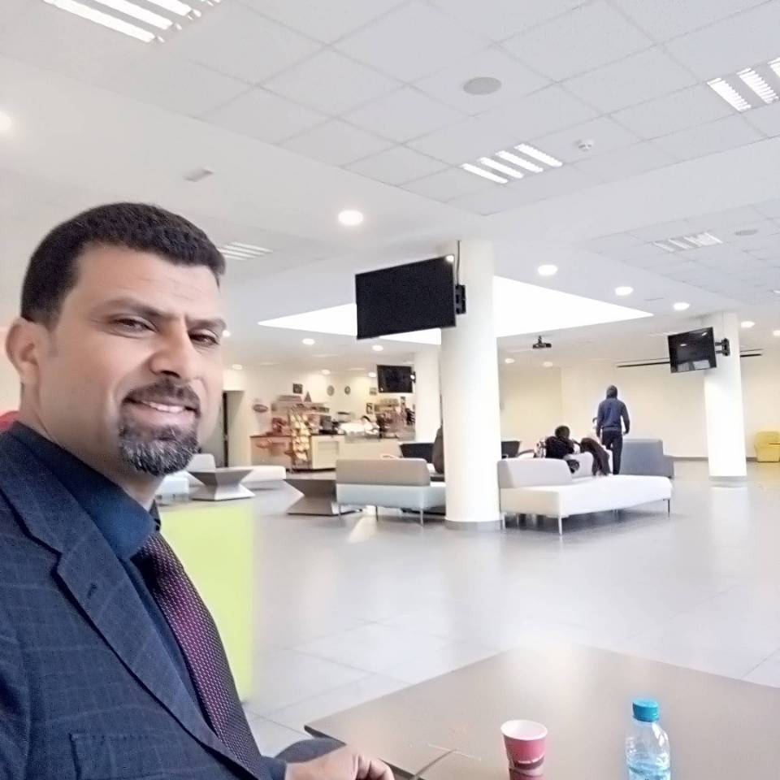 **Mehdi Dabbabi**

Tunisian Man

04/11/1977

Married

Address: Doualy 2143 Gafsa ,Tunisia

Phone: 00216 98910786

Email: mehdi.dabbabi@rns.tn/dabbabi.mehdi@yahoo.fr

**WORK EXPERIENCES**

2022-up to date:

* General public health administrator

2020-2022:

* Central Administration Manager.Teaching Activity

2018-2019:

* Teaching at the High School of Engineers of Gasfa , PROJECT MANAGEMENT course

2017-2019:

* The Director of the School of Nursing Sciences,
* Director of the Basic Health Group
* Chief public health administrator.
* Assistant Director of Central Administration.

2016-2017:

* Teaching at the High School of Engineers of Gasfa , PROJECT MANAGEMENT course

2015-2016:

* Teaching at the High School of Engineers of Gasfa , PROJECT MANAGEMENT course

2012-2016:

* Head of Administration and Finance Department in the basic health group Gafsa.
* Assistant Director of Central Administration

2011-2012

* Teaching the subject of taxation at the Higher Institute of Technological Studiesof Gafsa

2011-2012

* Public health advisor administrator
* Head of a central administration department in charge of the Information and Statistics Office in the Regional Health Administration Gafsa.
* Public Health Administrator, director of the basic health group Gafsa :Class 1 hospital establishment.

2009-2011

* Public Health Administrator,director of the local hospital in Mdhilla.

2009-2011

Teaching School of Nursing Sciences in Gafsa COMMUNICATION /HEALTH AND STRUCTURAL ENVIRONMENT course

2006-2009

* Public Health Administrator in Regional Health Administration

Gafsa

**TRAINING -WORKSHOP-CONFERENCES**

28/09/2019-04/10/2019:

* Participation in the Seventh Maghreb University of Public Health ( ORAN, ALGERIA)
* " Development and health. "

15/04/2019-16/04/2019:

* Participation in the Second Arab Conference on Public Health(CASABLANCA, MOROCCO)
* 0“Public Health."

04/04/2019-06/04/2019:

* Participation in a training course on the public procurement system( TUNIS,TUNISIA)

"TUNEPS Online Public Procurement System

21/03/2019-21/03/2019:

* Participation in workshop at the invitation of the Civil Society Coalition in Gafsa and Sidi Bouzid(TUNIS,TUNISIA)
* "For better health care for mothers and children"

19/02/2019-19/02/2019:

* Participation Participation in the Forum at the invitation of the Association of Our Health and Doctors of the World Belgium in Africa (TUNIS,TUNISIA)
* " Healthy Democracy and Participatory Planning "

14/02/2019-14/02/2019

* Participation in a training course on the AGILIS (TUNIS,TUNIISA)
* " Electronic refueling card system."

16/12/2018-16/12/2018

* Participation with a lecture invitation of the Association of Our Health and Doctors of the World Belgium.( MEDICAL AMBULANCE SPACE 06 IN GAFSA,TUNISIA)
* "Communication Obstacles and How to Overcome them."

22/11/2018-22/11/2018

* Participation with a lecture invitation of the Association of Our Health and Doctors of the World Belgium.( MEDICAL AMBULANCE SPACE 06 IN GAFSA,TUNISIA)
* “The career path of a public official in the Medical."

17/11/2018-17/11/2018

* Participation in workshop at the invitation of the National Office for Family and Human Urbanization , in collaboration with the staff of the Basic Health Complex (GAFSA,TUNISIA )
* " Rights and Duties in the Public Service Law "

01/11/2018-01/11/2018

* Leading a lecture for the benefit of health officials.( MEDICAL AMBULANCE SPACE 06 IN GAFSA,TUNISIA)
* "Strategy and Functions of Human Resources."

25/07/2018-27/27/2018

* Participation in the third summer university workshops(HAMMAET,TUNISIA)
* " Management Competencies in the Field of Health"

10/05/2018-12/05/2018

* Participation in the Eighth International Conference (UNIVERSITY OF MUS ,TURKEY)

18/04/2018-18/04/2018

* Participation in the activities of the training day Human Resources Management(MONASTIR,TUNISIA)

20/03/2018-24/03/2018

* Participation in the Fifth International Session of Public Health and Management of Program Development (SHANDAGAR,INDIA)

11/12/2017-17/12/2017

* Participation in the Sixth Maghreb University of Public Health(SOUSSE,TUNISIA)

26/07/2017-27/07/2017

* Participation in the second summer university workshops(HAMMAET,TUNISIA)
* " Management Competencies in the Field of Health"

21/03/2017-23/03/2017

* Participation in the Human Resources Management Forum(PARIS,FRANCE)

06/10/2016-08/10/2016

* Participation in the 17th session of the Tunisian Association of Hospital Management (SOUSSE,TUNISIA)

22/09/2016-23/09/2016

* Participation in the fourth days of public health (RAN, FRANCE)
* " The relationship of public health to the ocean at the Graduate School of Health Ran "

29/07/2016-30/07/2016

* Participation in the second summer university workshops(MONASTIR,TUNISIA)
* " Management Competencies in the Field of Health"

28/05/2016-02/06/2016

* Participation in the Fifth Maghreb University of Public Health(RABAT,MOROCCO)
* " Quality in Public Health and Modern Behavior Methods "

22/03/2016-24/03/2016

* Participation in the Human Resources Management Forum(PARIS,FRANCE)

12/09/2015-02/10/2015

* Participation in a Training course in the field of health(PEKIN,CHINA)

2013-2015

* Participation in the activities of the Médecins World Project (GAFSA,TUNISA)
* " Participatory Approach to Improving Health Care and Services "

01/01/2012 - 02/07/2012

* Training to advance to the position of Administrator, Public Health Advisor(the National School of Administration,TUNIS,TUNISA)

2005-2006

* Training for forming intermediate tires, sub-category A2 National School of Administration,TUNIS,TUNISA)

2003-2004.

* Training stage in information and communication technology: The National Center of Computer Science

**Qualifications**

2003-2004 : Certificate of qualification in postgraduate studies specialized in communication

and information technology at the National Center for Computer Science

* Excellent
* Higher School of Communication of Tunis

2008-2002: Bachelor Degree in Accounting Sciences

* Excellent
* Faculty of Economic Sciences and Management of Tunis El Manar 20

2007-2008 : Baccalaureate Economics and Management

**COMPUTER SKILLS**

-Operating system: Windows

-Tools :Microsoft Office(Word,Excel,Power point,Access),SPSS..

**LANGUAGES**

Arabic

English

French

**OTHERS**

-Internet

-Sport